Skill and Job Recommender

**Project Design Phase-II**

**Technology Stack (Architecture & Stack)**

**Technical Architecture:**

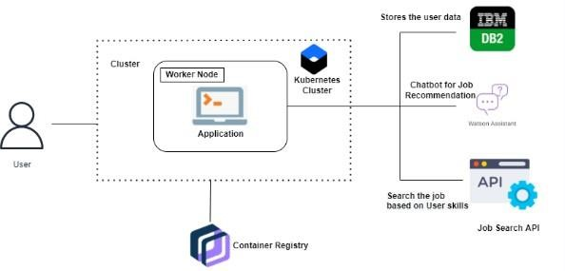

Skill and Job Recommender

**Table-1 : Components & Technologies:**

|  |  |  |  |
| --- | --- | --- | --- |
| **S.No** | **Component** | **Description** | **Technology** |
| 1. | User Interface | How user interacts with application ( Web UI and Chatbot) | HTML, CSS, Bootstrap, Materialized CSS, jQuery, JavaScript, Figma. |
| 2. | Application Logic-1 | User can login after creating an account and search for jobs based on their skill set. | Python |
| 3. | Application Logic-2 | Users can make use of chatbot to get job and skill recommendations | IBM Watson Assistant |
| 4. | Cloud Database | Database Service on Cloud | IBM DB2, IBM Cloudant |

**Table-2: Application Characteristics:**

|  |  |  |
| --- | --- | --- |
| **S.No** | **Characteristics** | **Description** |
| 1. | Security Implementations | List all the security / access controls implemented (SHA256) |
| 2. | Scalable Architecture | It follows highly scalable technologies that allows application to handle increase in large user data’s, workload and perform any operation without any problem. |
| 3. | Availability | Justify the availability of application (e.g. use of load balancers, distributed servers etc.) |
| 4. | Modifiable | It is highly Modifiable and Maintenance requires low cost, compared to other application |